**Department of Systemics**

**School of Computer Science**

University of Petroleum and Energy Studies

cid:image003.png@01D81F60.F8BDA810

**ADVANCE DATABASE MANAGEMENT SYSTEM**

**LAB FILE**

Submitted by

**Akshat Negi**

**R2142220414**

**Batch - 2**

B.Tech Computer Science and Engineering(CSF)

Submitted to

**Dr. KOTHA VENUGOPALCHARY**

Assistant Professor (SS)

SOCS, UPES

**LAB EXPERIMENT – 7**

**Title: To understand the concepts of Index.**

**Objective:** Students will be able to implement the concept of index.

**1. Execute the following index related queries:**

***1) Create an index of name employee_idx on EMPLOYEES with column Last_Name, Department_id***

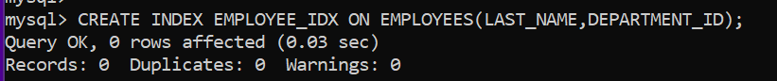

***2) Find the ROWID for the above table and create a unique index on employee_id column of the EMPLOYEES.***

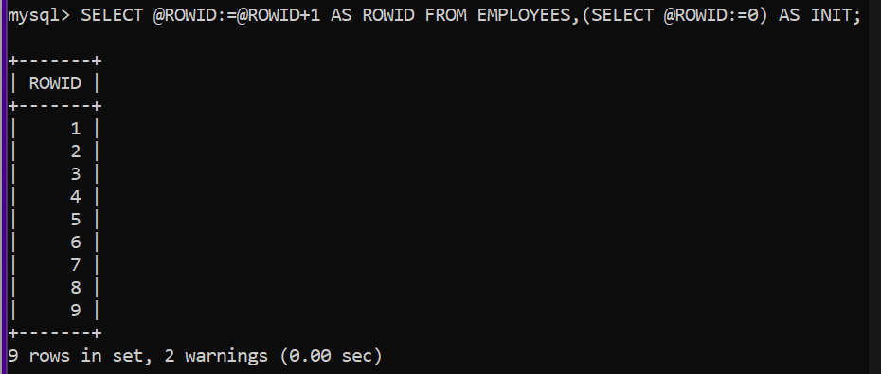



***3) Create a reverse index on employee_id column of the EMPLOYEES.***

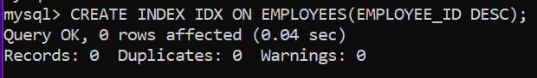

***4) Create a unique and composite index on employee_id and check whether there is duplicity of tuples or not.***

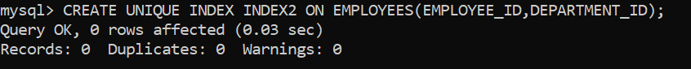

***5) Create Function-based indexes defined on the SQL functions UPPER(column_name) or LOWER(column_name) to facilitate case-insensitive searches(on column Last_Name).***

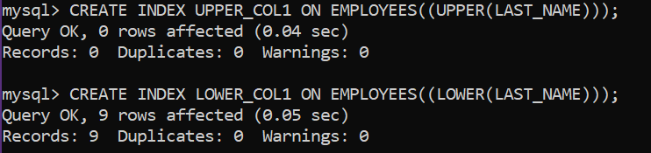

***6) Drop the function based index on column Last_Name.***

